A Quick User Manual

*SignalBrowser* – A psychophysiology Signal Processing and Analysis Toolbox

SignalBrowser is a graphic user interface software tool written in Matlab to load, process and analyze psychophysiological data (ECG, respiration and skin conductance). This software can do the following:

* Filter and process ECG, respiration (RESP), and skin conductance (SCL)
* Automatically detect and subsequently manually edit ECG R-peaks to compute the RR or interbeat-interval (IBI) signal
* Compute ECG derived respiratory signal (EDR)
* Compute several Heart Rate Variability (HRV) measures of IBI in the time (Mean RR, RMSSD…) and frequency (ultra low, low and high relative and absolute frequency power) domains.
* Compute several frequency domain measures of RESP and EDR
* Compute Galvanic skin conductance level (SCL) or responses (SCR)
* Compute the time frequency power spectrum using wavelet (Morlet, Dog, Paul) or Fourier Transforms (second screenshots on next page, bottom plot)
* Compute the time course of the low (LF), high (HF) and low to high ratio (LF/HF) of the HRV frequency spectrum and related frequency of the peak respiratory sinus arrhythmia (RSA; frequency of the high frequency HRV power spectrum) and corresponding respiratory signal (RESP, EDR) as a measure of the sympathetic (LF) and parasympathetic (HF) balance of the autonomic nervous system.
* HRV or RESP/EDR power spectrum analyses can be performed using various computational methods (Fourier transform, Wavelet, Welch, Welch-Spargle, Autoregressive based power spectrum density calculation) and several conditioning window filtering (Hamming, Hanning, Square, Barlett, Blackman…)
* Export outcome measures in a file for each of the defined analysis “Sample” data segments

The *RR editing* view allows you to principally load ECG and other signals and compute/edit ECG R-peaks to extract the RR or interbeat-interval signal (IBI). It can also allow you to define

1. Some “Sample” data segments (manually or interactively with a click and drag of the mouse) from which outcome measures are computed
2. Some noisy “Signal” data segments (manually or with the mouse) which are excluded from the computation of outcome measures.

The *All Signal* view allows you to scroll through and visualize all signals (IBI, RESP, EDR, SCL), as well as outcome measures for each of the “Sample” data segments. It also computes and displays the time-frequency power spectrum of IBI and the time course of the autonomic nervous system (ANS) represented by the low, high and low to high ratio of the HRV frequency spectrum and related time course of the frequency of the peak respiratory sinus arrhythmia (RSA; frequency of the high frequency HRV power spectrum) and corresponding respiratory signal (RESP, EDR)

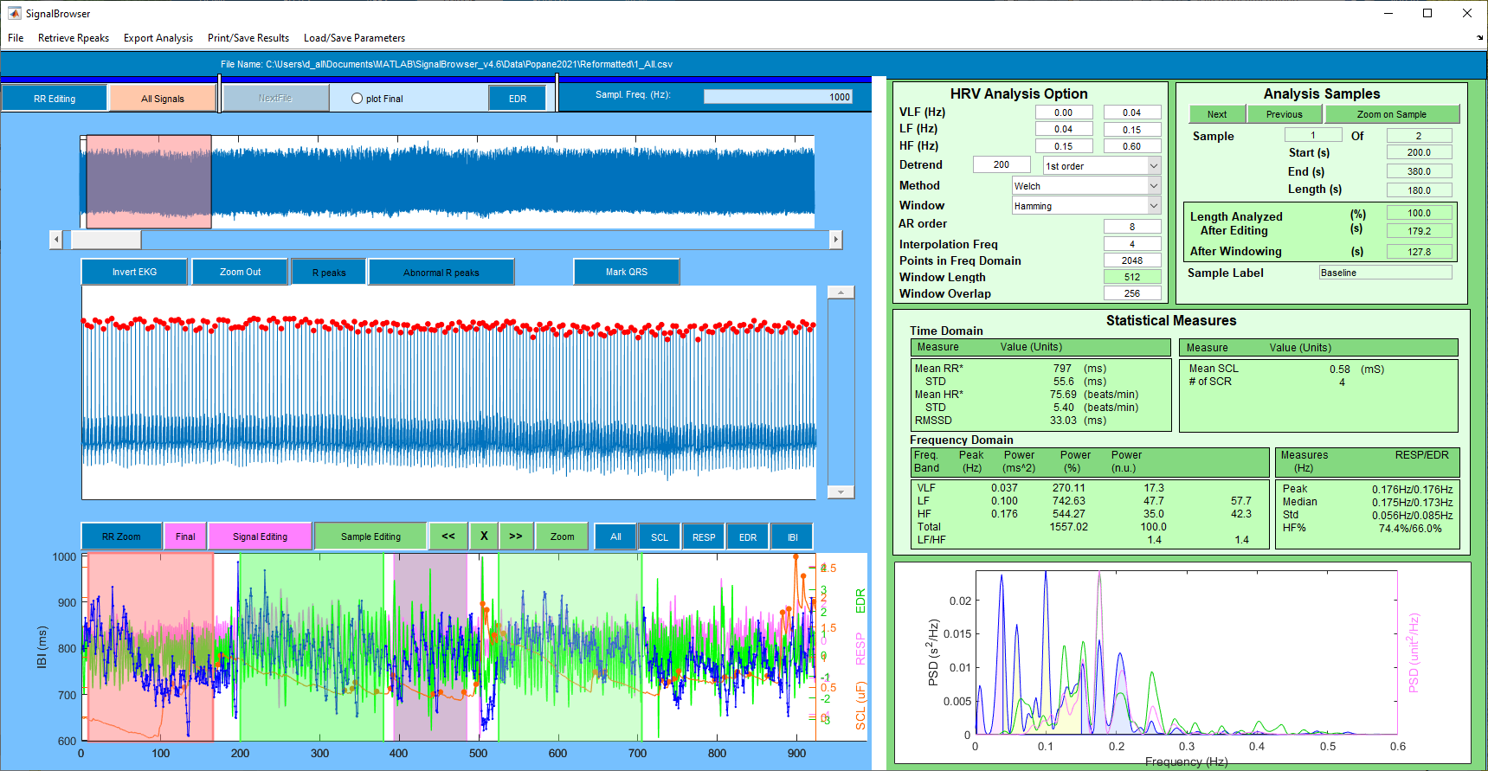

*Zoom in* (red) window for R-peaks editing

**RR Editing View – Sample Editing View**

Toggle between RR editing/All signals view

Display “All” or selectively SCL (skin conductance), RESP (respiration), EDR (ECG derived respiration), IBI (interbeat intervals) data

Zoom in to the selected *Sample* segment. Scroll left (<<) or right (>>) or delete a given *Sample data segments*. Analysis metrics on the right are computed on the selected *Sample* segment

Automatically find R peaks

*Zoom out* (double the range of the time and IBI axis limit at every click)

Compute ECG derived respiration (using amplitude modulation of R peaks)

Invert ECG if necessary

Scroll left/right the *zoom in* R-peaks editing window

**Automatic and manual R-peaks editing window**

**Signal viewing for creating and editing “Signal” and “Sample” data segments. “Signal” magenta shaded regions define noisy data segment.**

**“Sample” green shaded regions define analysis data samples segments.**

**Full time view of ECG data**

**HRV analysis option editing**

**Analysis Sample data segment selection and characteristics**

Data Measures (HRV, SCL level and response, Respiration freq.) for the selected Analysis Sample window

Freq spectrum for HRV, Respiration and EDR for the selected Analysis Sample window

*Sample* windows (green) defining data segments to be analyzed

Toggle between *Signal* and *Sample* editing view and editing

*Zoom in* (red) window for R-peaks editing

*Signal* window (magenta) defining noisy data segments

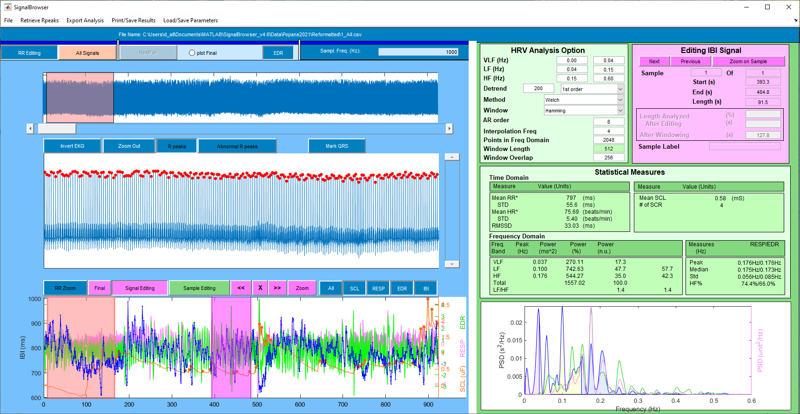

**RR Editing View – Signal Editing View**

*Zoom in* window for R-peaks editing

Toggle between *RR editing view* and *All signals view*

Display “All” or selectively SCL (skin conductance), RESP (respiration), EDR (ECG derived respiration), IBI (interbeat intervals) data

Zoom in to the selected *Signal* segment window. Scroll left (<<) or right (>>) or delete a given *Signal* data segment.

Automatically find R peaks

*Zoom out* (double the range of the time and IBI axis limit at every click)

Compute ECG derived respiration (using amplitude modulation of R peaks)

Invert ECG if necessary

Scroll left/right the R-peaks *zoom in* window

**R-peaks automatic and manual editing window**

**Signal viewing for creating and editing “Signal” and “Sample” data segments. “Signal” magenta shaded regions define noisy data segments.**

**“Sample” green shaded regions define analysis data segments.**

**Full time view of ECG data**

**HRV analysis option editing**

**Editing IBI “Signal” segment selection and characteristics**

Data Measures (HRV, SCL level and response, Respiration freq.) for the selected Analysis Sample window

Freq spectrum for HRV, Respiration and EDR for the selected Analysis Sample window

*Signal* window (magenta) defining noisy data segments

*Zoom in* window for R-peaks editing

Toggle between *Signal* and *Sample* editing view and editing

**All Signals View**

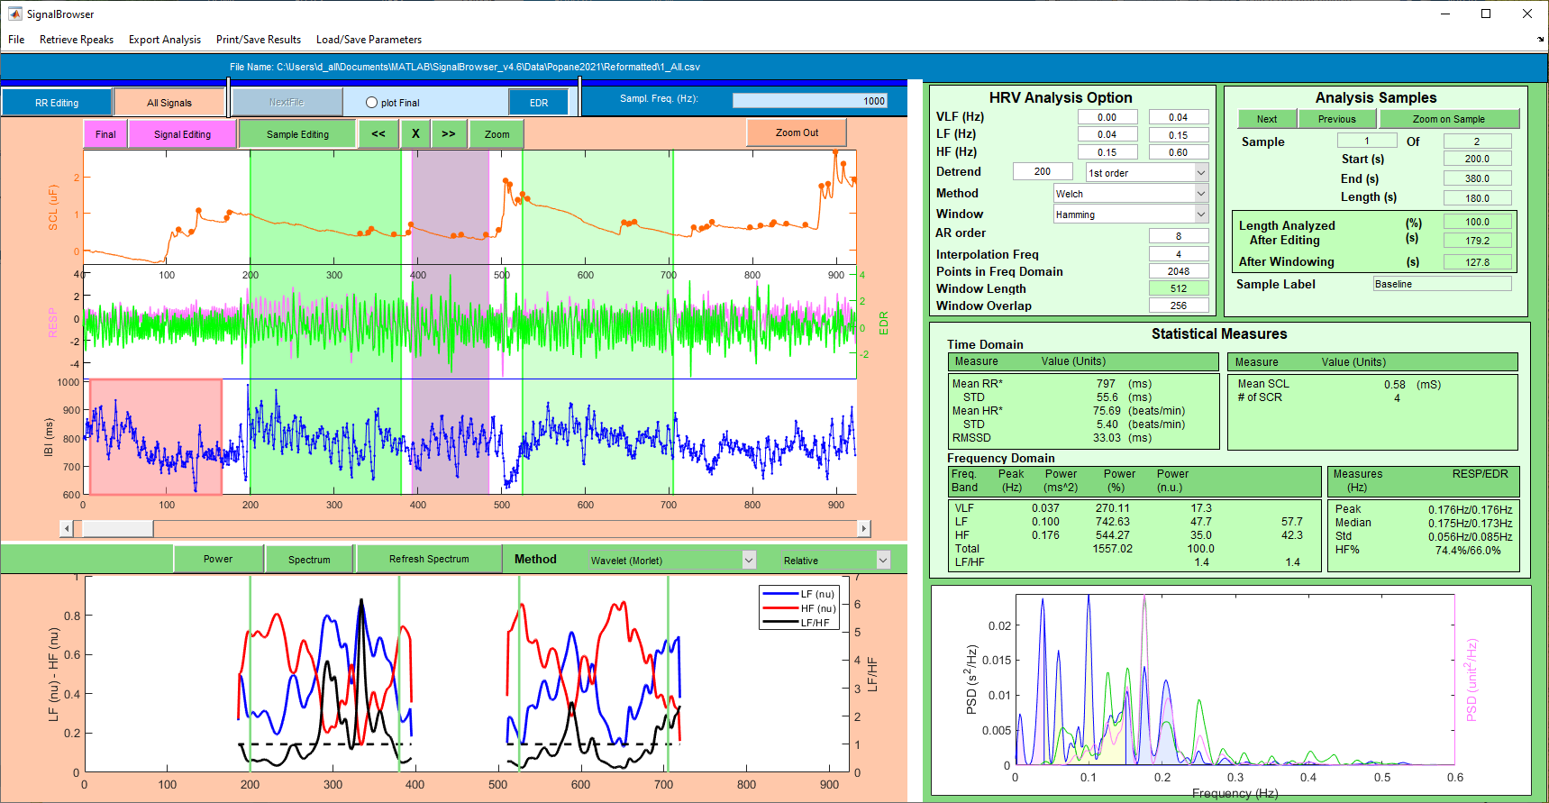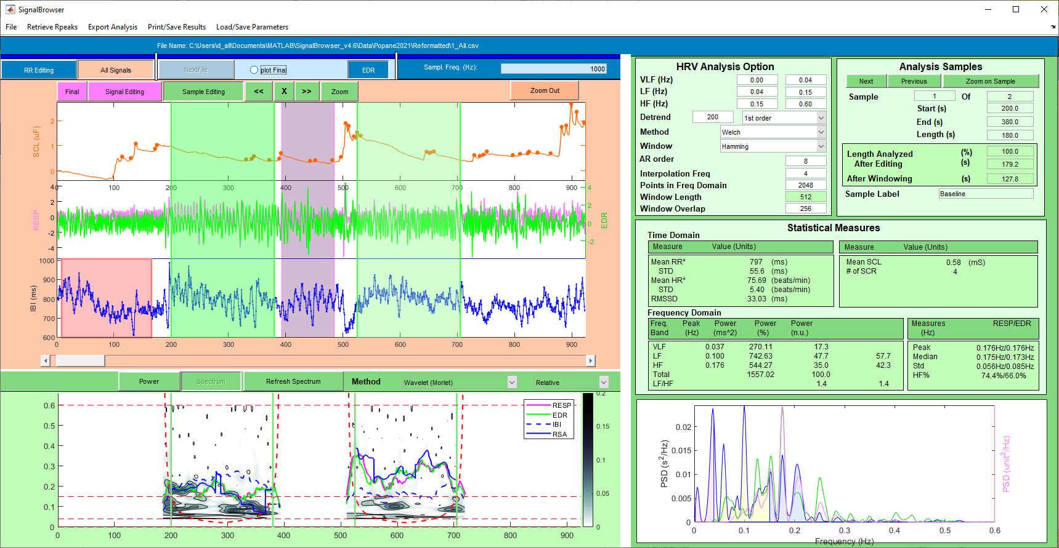

Toggle between HRV *Power* and time frequency *Spectrum* view

**HRV *Power* (top) or time frequency *Spectrum* view (bottom)**

**Signal viewing showing SCL/ RESP & EDR / IBI signal data in separate plots**

Zoom in to the selected *Sample* segment. Scroll left (<<) or right (>>) or delete a given *Sample data segments*. Analysis metrics on the right are computed on the selected *Sample* segment

Toggle between *Signal* and *Sample* editing view and editing

*Zoom out* (double the range of the time and IBI axis limit at every click)

**HRV analysis option editing**

**Editing IBI “Signal” segment selection and characteristics**

Data Measures (HRV, SCL level and response, Respiration freq.) for the selected Analysis Sample window

Freq spectrum for HRV, Respiration and EDR for the selected Analysis Sample window

Select Spectrum Method